1. **LINE DETECTION CAPABILITIES**

Gordan Konevski & Luca Brodo (Coding)

Giuseppe Scalora

(Construction)

1. OBJECTIVE

One of the essential goals of the vehicle in question is to allow the central unit (itself composed of an Arduino and a Raspberry Pi) to govern the behaviors of the vehicle autonomously. Two essential elements are required for such a task, one being a specified ‘task’ that the vehicle would be ordered to complete and the other being ‘the direction’ to follow.

Both elements were already predetermined. The direction was outlined by a path marked with black tape, in the form of a loop, while the task itself was as simple as driving the vehicle forwards, avoiding obstacles and following the black tape in the meantime.

1. INFRARED SENSORS

In order to incorporate the line-following capability, a pair of small infrared sensors were glued to the sides in parallel and connected to the Arduino board. The behavior of the motors was closely linked to the signals provided by the IR sensors, so whenever one sensor would detect a change, i.e. detect the line, the motors would change their course of action correspondingly. A notable issue was the inability for the sensors to function normally even with the slightest reflectivity on any surface.

The code for the sensors was written using the Arduino IDE.

1. THE FUNCTION OF THE MOTORS IN THE CONTEXT OF THE IR SENSORS

The vehicle was designed to always move forwards by default. Only with change in the environment would a different direction be taken. The angle in which the vehicle was situated was not taken into account, rather the change of directions was simply done by changing the speeds of the motors with a series of ‘if’ statements and corresponding functions. As an example, if the left sensor were to detect the line, the left motor would decrease its speed, allowing the right motor to change the direction of movement. A unique function was also implemented, where if both sensors were to detect the line, the vehicle would turn in alternating directions, allowing it to position itself on the line. This function was a bit difficult to implement due the failure of one of the motors to supply enough power, thus constantly skewing the vehicle to the side. Regardless, the vehicle was still capable of following the black tape line successfully.

1. INTERACTION BETWEEN THE SENSORS AND OTHER ELEMENTS

The sensors were designed to only function when no other behavior altering functions were in use. Thus, if the ultrasound sensors were to detect an object, the signals of the IR sensors would be ignored, until the action taken by the. If manual control was activated via the Qt interface, the signals would, again, be ignored. Its only interaction with the other elements was to deactivate.

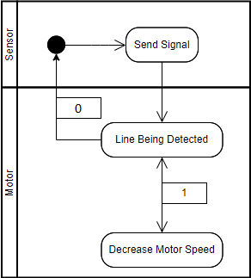

*Activity diagram showcasing the interaction between one sensor and its corresponding motor*

1. **MOTIVATION**
2. MAIN OBJECTIVE

The goal of the project was to develop a small autonomous vehicle. Set on the floor were some black lines (ordinary black tape), set up in a way that would resemble a simple driving track. The entire development process would revolve around such a track, as it represented the pathway which the vehicle itself had to follow autonomously. A second, equally important element was the concept of obstacle avoidance. Not only was the vehicle tasked with following a certain path, but it also had to demonstrate an ability to avoid physical obstructions, albeit in a simple manner that mostly shed light on its potentiality rather than showcased any sophisticated maneuvering procedures or complex real-time decision making. Finally, a third, just as equally important task was the implementation of a Qt-based interface, with which a user could control the vehicle manually through their device. This eventually led to an interface only limited to a computer program with a rather complex setup process - at least to users who are unfamiliar with the hardware and software at hand. To summarize, a vehicle was to be constructed that would be capable of autonomously following a set path, avoid obstacles and would also allow a user to control its movement manually, whenever requested.

1. RESOURCES AND MATERIALS

A lack of online resources and demonstrations led to some difficulty in the end stages of the development process, the Qt interface and its connectivity to the vehicle being a notable example. Regardless, the tasks were still manageable.

The actual physical materials themselves were composed of:

* A simple wooden chassis, with the front part being divided into three, and the bottom part being somewhat elevated
* A pair of low-cost IR sensors
* Three low-cost ultrasound sensors
* One pair of motors with their respected speed control board (one of the motors will prove to be faulty, though not unusable)
* One Arduino Uno board
* One Raspberry Pi board and one Raspberry Pi camera
* Elementary electronic elements form a basic electronics kit (e.g. jumper cables, breadboards)
* Two batteries
* Duct Tape

1. LIMITATIONS

The biggest limitations were mostly hardware and environmentally based. For instance, as mentioned earlier, one of the motors proved to be faulty. The problem laid in the fact that the motor could not output the speed necessary in order to keep up with its corresponding motor. Even though a software-based solution was implemented (using the Arduino interface to manipulate the speeds), it only partially mediated the problem. Nevertheless, the interaction between the different devices and the central control unit would later produce the desired results.

One notable issue was linked to the hardware used, i.e. the hardware limitations of the sensors themselves meant that the vehicle could only work in specific environments. The ultrasound sensors, as an example, could only reflect signals from certain materials, and the IR sensors could not function properly on reflective surfaces (changing its sensitivity could only help so much).

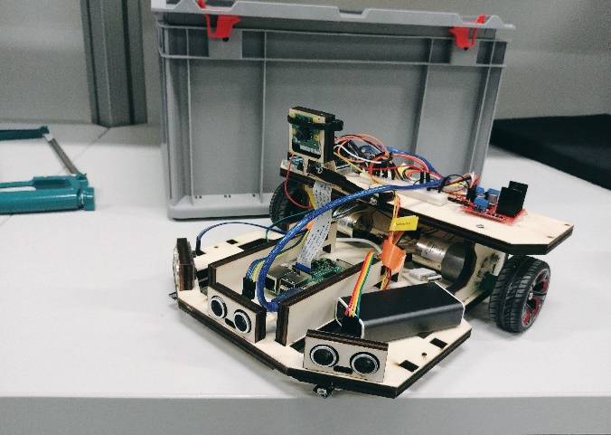

*The final result of the vehicle*